Right of withdrawal

You has right to withdrawal from the contract within 14 days from receiving goods without giving reasons. In order to exercise your right of withdrawal, you must inform the Seller

MODE PLUSS
Fashion store Bergs
Elizabetes iela 20
Riga, LV-1050
LATVIA
Ph. +371 67288393
e-mail: bergs@bergs.lv
by means of a clear statement (e.g. a letter sent by post or e-mail ) of your decision to revoke this Agreement. You can use the following sample withdrawal form, which is not mandatory.

Withdrawal form
Please fill out this form only if you want to cancel the contract

Date: _______________

Name of the Seller: MODE PLUSS SIA
Address of the Seller: Elizabetes street 20, Riga, LV-1050 , LATVIA
Phone number of the Seller: +371 67288393
E-mail of the Seller: bergs@bergs.lv

Name of Consumer: _______________________________________

Address of Consumer: ______________________________________
_______________________________________________
_______________________________________________
Your Purchase Name: _________________________________
Ordered on: _______________________________________
Received on: _______________________________________
Your Purchase documents: ______________________________
____________________________________________________________________

I hereby cancel the contract concluded by us for the purchase of the above goods.

Signature of the consumer (only for notifications on paper): _________________

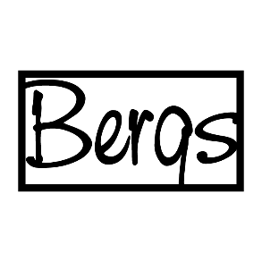
Consequences of withdrawal

The Seller shall reimburse the costs of the returned goods to the customer within 14 business days from the date Seller receives the letter of the withdrawal. The Seller may withhold the refund until the Seller has received the goods back or until the Buyer has provided confirmation to the Seller that the goods have been returned.

The Buyer is obligated to return the goods to the Seller WITHIN 14 DAYS after sending the withdrawal letter. Return address:
MODE PLUSS SIA
Fashion store Bergs
Elizabetes street 20
Riga, LV-1050
LATVIA
All expenses for returning the goods to the Seller shall be covered by the Buyer.
According to Section 12, paragraph six of the Consumer Rights Protection Law of the Republic of Latvia, “the consumer is responsible for ensuring the quality and safety of the goods during the exercising of the right of withdrawal.
The Seller reserves the right to refuse the Buyer`s right of withdrawal or the Seller can deduct compensation in the case that
- the goods do not correspond to their original condition;
- the goods are damaged;
- the goods have been worn and/or washed;
- the goods have spots;
- original brand-, price tags have been removed;
- the deadline for return the goods is overdue.
We inform the Buyer, if we find that the value of the retutned goods has been lost, we will apply to the court for compensation for the damage caused to our company as a result of the consumer`s actions.

_____________________________________________________________________
MODE PLUSS SIA, store Bergs, Elizabetes street 20, Riga, LV-1050 LATVIA
Phone: +371 67288393, e-mail: bergs@bergs.lv, www.bergs.lv

